EXPT NO:6A | DATA VISUALIZATION USING POWER BI

AIM:
To import, transform, analyze, and visualize data using Power BI Desktop and create interactive dashboards and reports for decision-making.

ALGORITHM:
- Start the Power BI application.
- Import the Research Student dataset into Power BI using Get Data.
- Load the dataset into Power BI.
- Check the columns and clean the data using Power Query if required.
- Remove duplicate records and handle missing values.
- Create required calculated fields/measures.
- Create a bar chart to compare student-related categories.
- Create a pie chart to display category-wise distribution.
- Create a line chart to represent trends between numerical attributes.
- Create a card visual to display important summary values.
- Add suitable titles, labels, filters, and slicers.
- Arrange the visuals into a Power BI dashboard.
- Analyze the visualizations and identify important patterns.
- Save the Power BI report.
- Stop.

OUTPUT:
Importing
Data into Power BI:
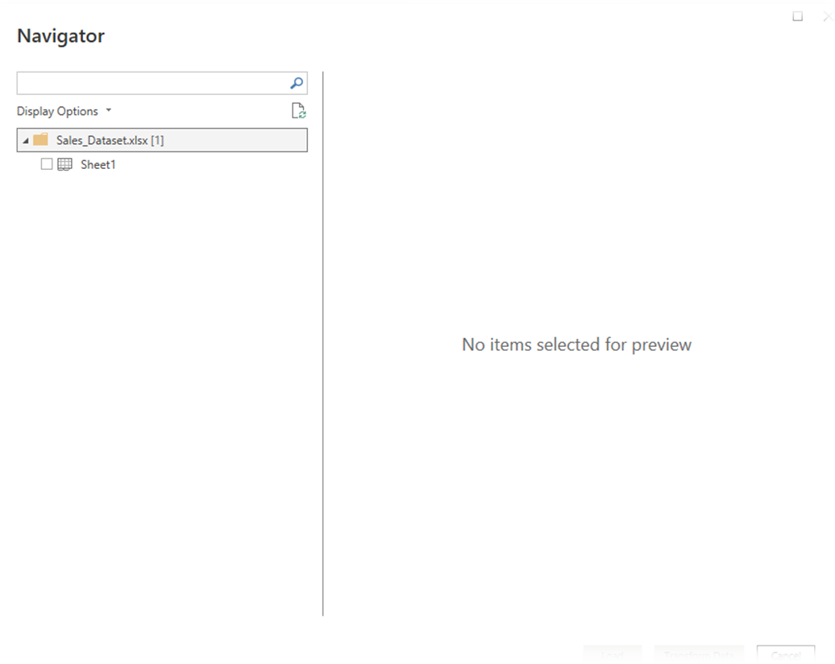

Imported dataset displayed in Data View:
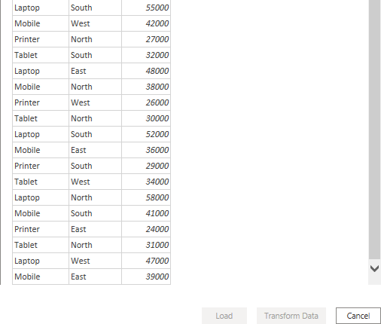

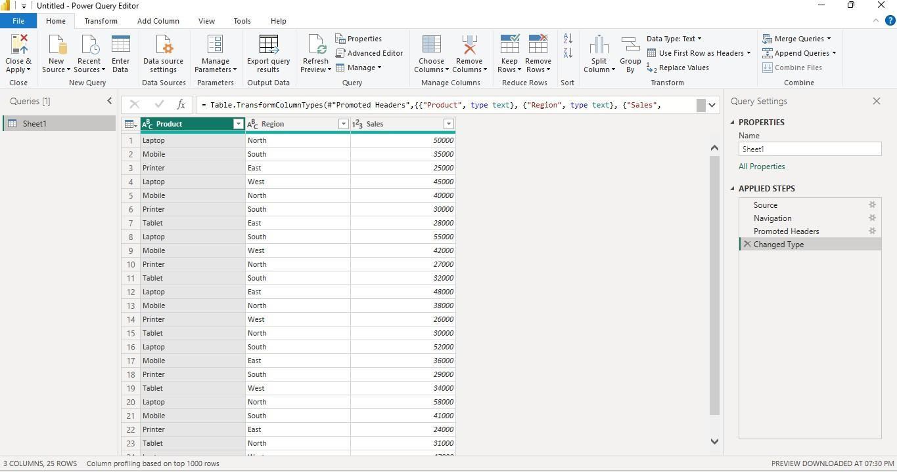
Cleaned dataset loaded successfully:
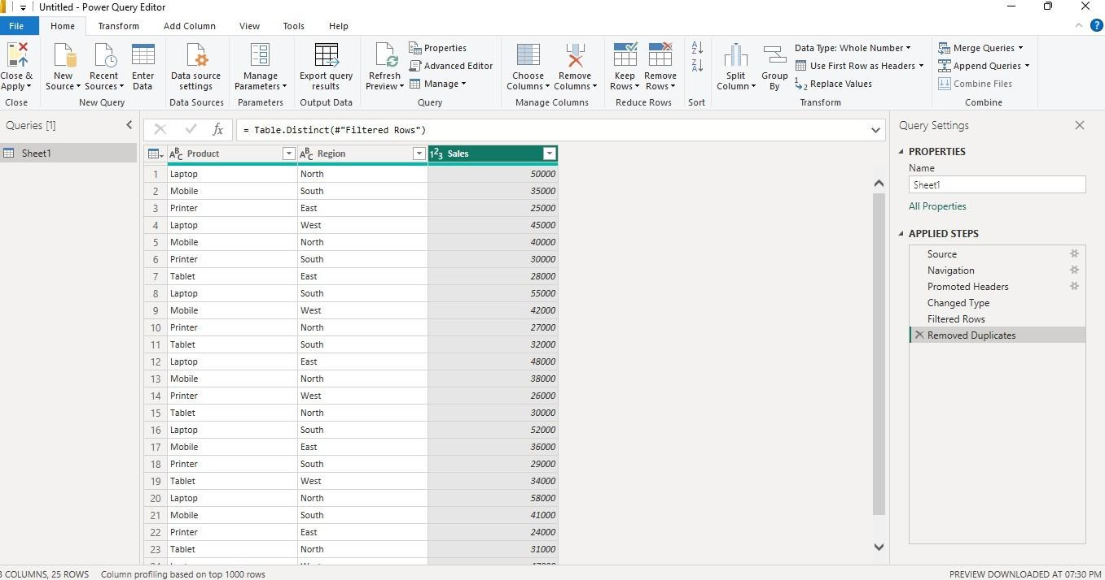
Creating a Bar Chart Product-wise Sales

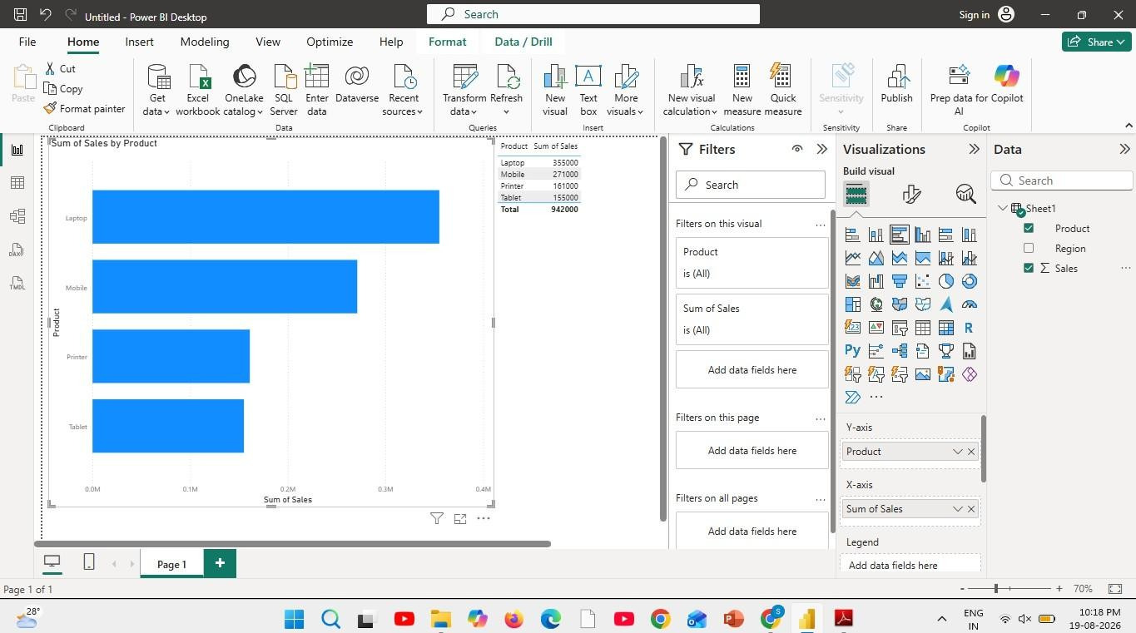
Sales comparison across products.
Creating a Pie Chart Sales Contribution
Percentage contribution of each product
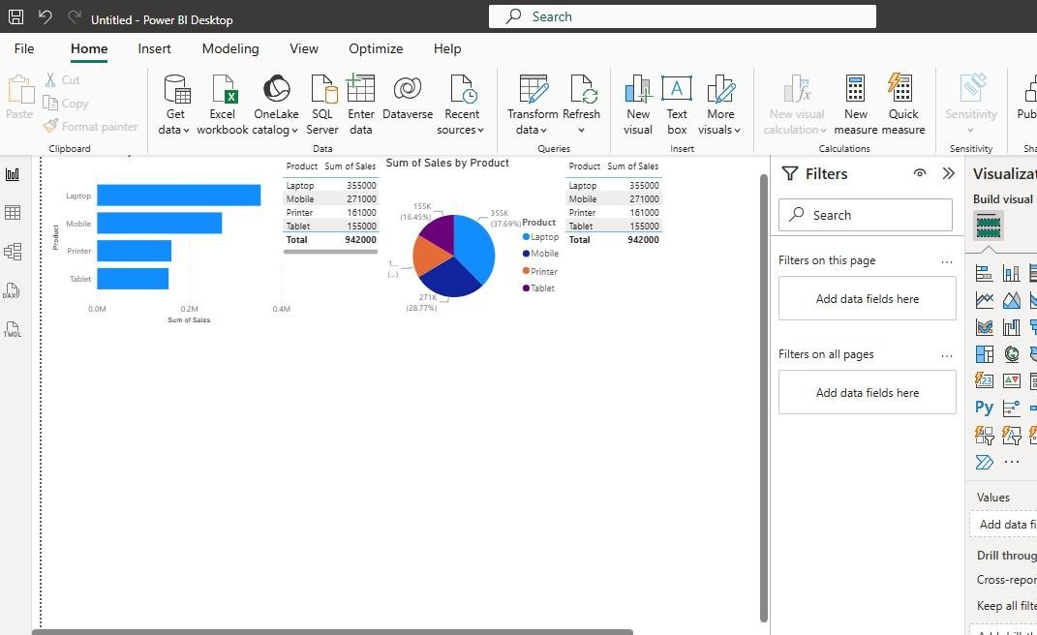

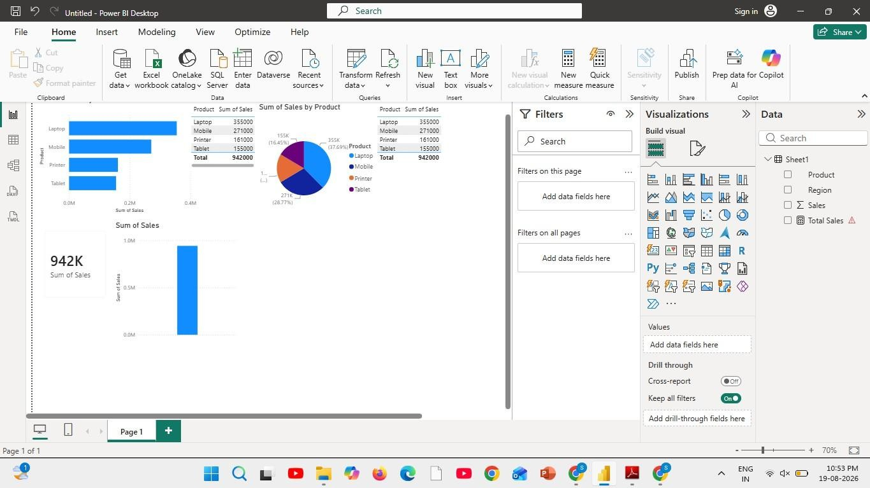
Creating a KPI Card
Creating Slicers:
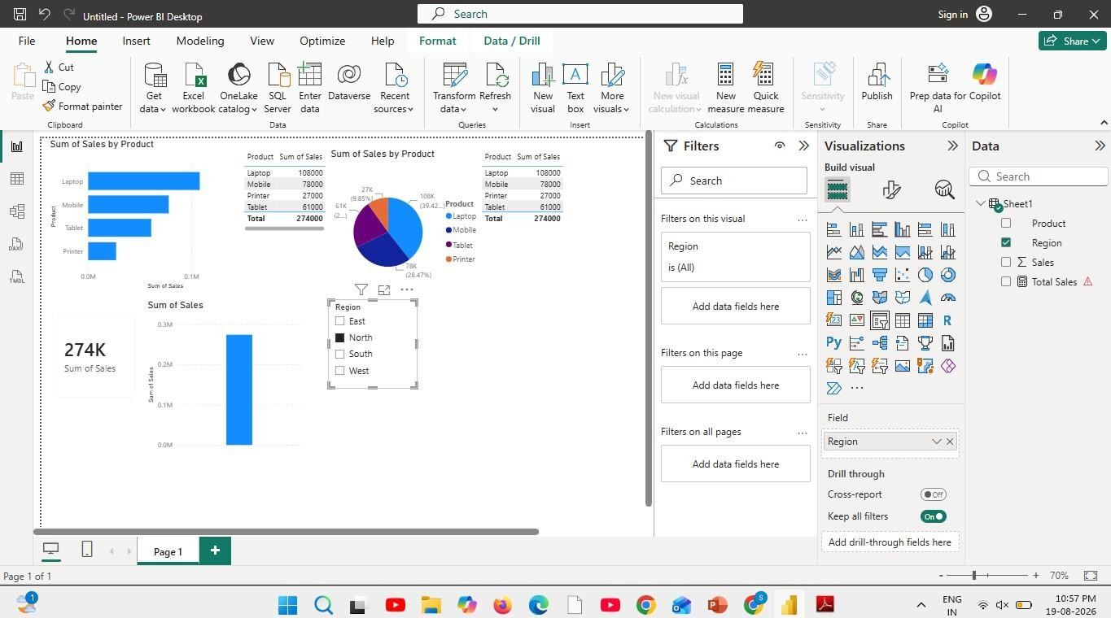
Creating DAX Calculations:

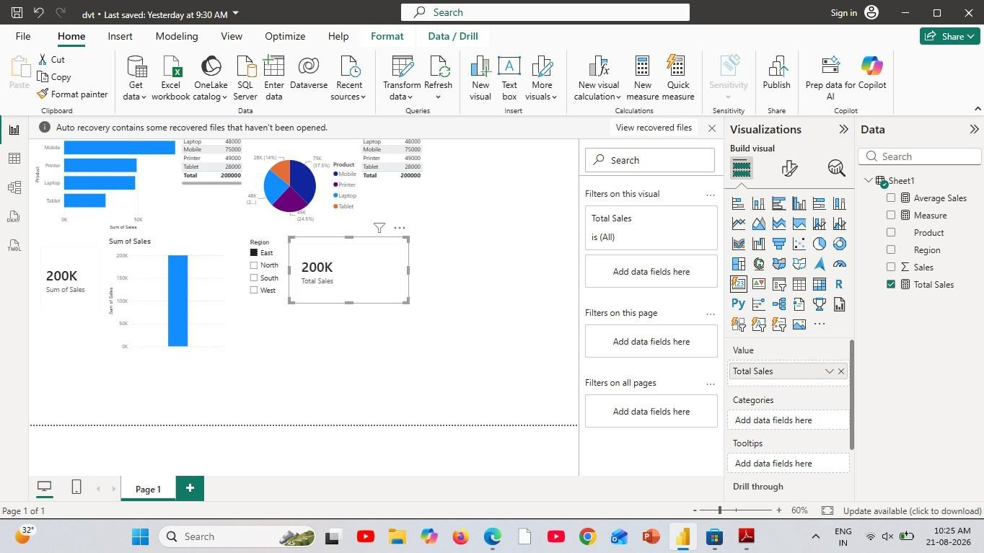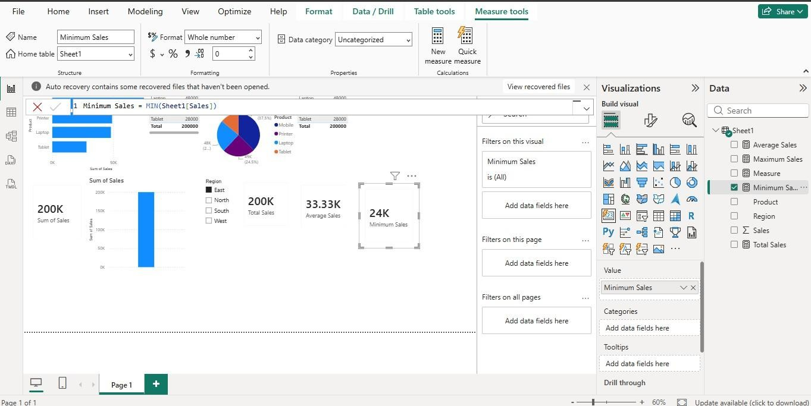

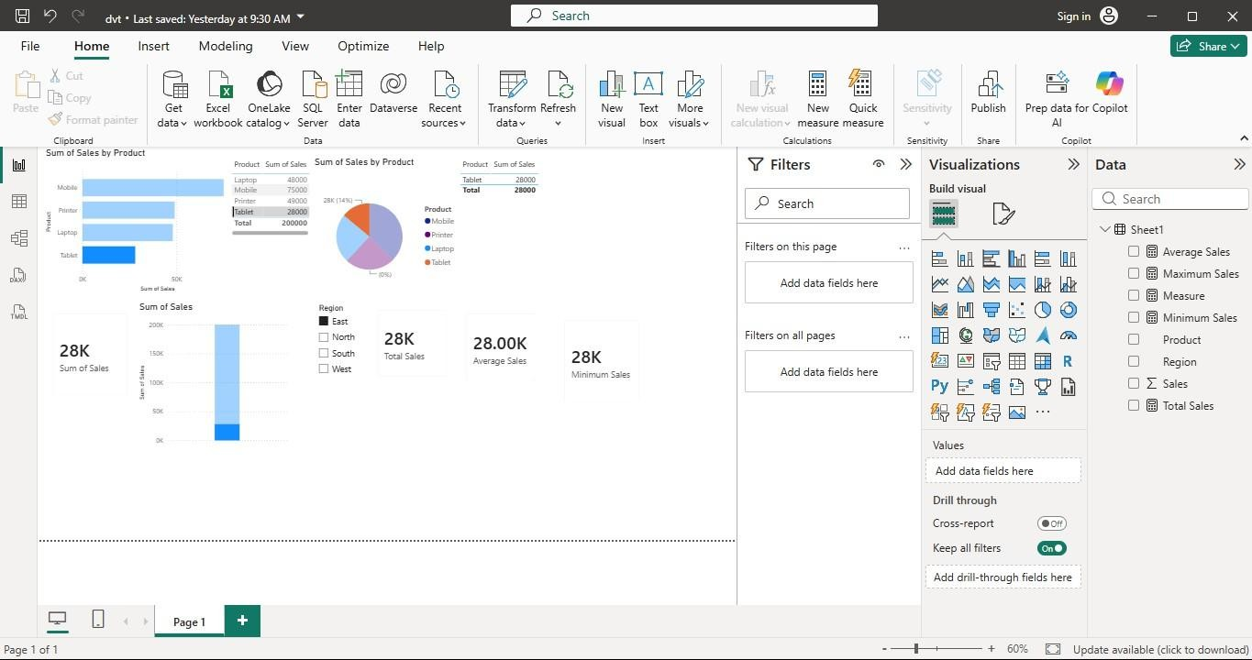
Creating Dashboard:
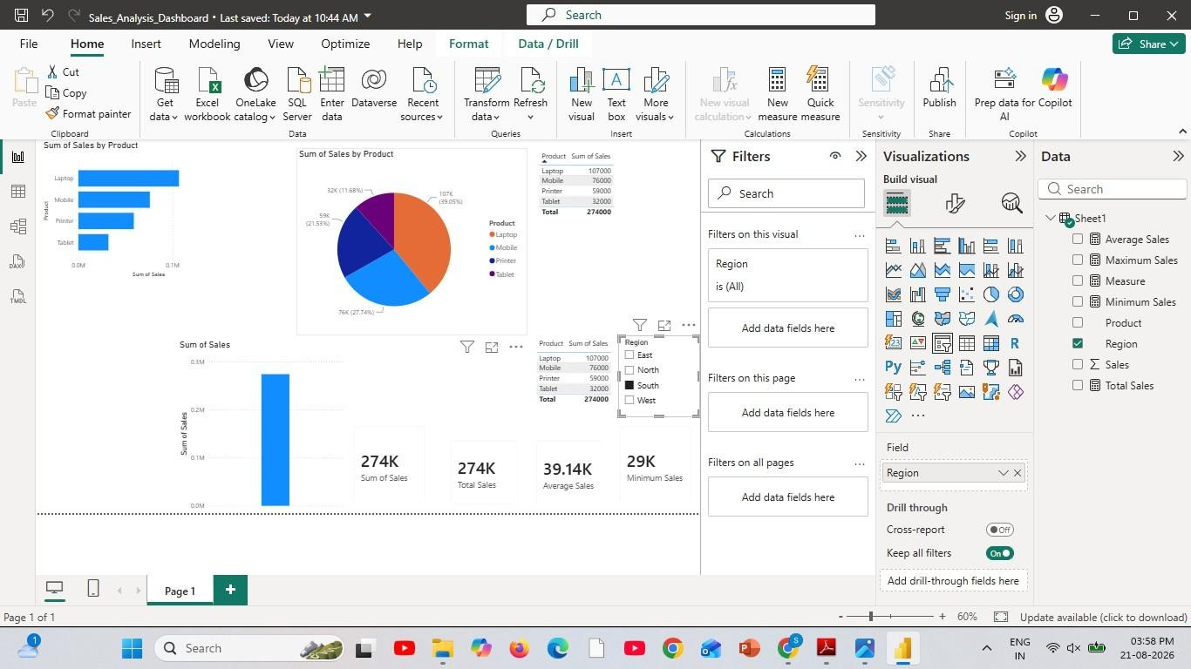

Result:

EXPT NO:6B DATA VISUALIZATION USING POWER BI
(ADVANCED STATISTICS ANALYTICS)
Aim:
To load the Students Performance dataset into Power BI, transform and clean the data using Power Query, create calculated fields and measures, and develop interactive visualizations to analyze student scores based on gender, race/ethnicity, parental education, lunch, test preparation, and subject-wise performance.
Algorithm:
ALGORITHM 1: IMPORTING DATA INTO POWER BI
Step 1 Open Power BI Desktop.
Step 2 Select Home → Get Data.
Step 3 Choose Text/CSV.
Step 4 Browse and select the StudentsPerformance.csv dataset.
Step 5 Click Load to import the dataset.
Step 6 Verify the imported columns and records in Data View.
ALGORITHM 2: DATA TRANSFORMATION USING POWER QUERY
Step 1 Select Transform Data.
Step 2 Open the Power Query Editor.
Step 3 Check column names and assign appropriate data types.
Step 4 Remove duplicate student records if present.
Step 5 Check and handle missing values in categorical and numerical columns.
Step 6 Clean and standardize gender, race/ethnicity, parental level of education, lunch, and test preparation course.
Step 7 Remove unnecessary columns if required.
Step 8 Click Close & Apply to load the transformed dataset.
ALGORITHM 3: ADVANCED DATA TRANSFORMATIONS
Step 1 Ensure Math, Reading and Writing Score columns are numeric.
Step 2 Check categorical columns and their data types.
Step 3 Handle missing or invalid score values if present.
Step 4 Create score groups where required, such as Low, Medium, and High.
Step 5 Create a Total Score field by adding Math, Reading and Writing scores.
Step 6 Create an Average Score field from the three subject scores.
Step 7 Click Close & Apply to load the cleaned model.
ALGORITHM 4: CREATING CALCULATED COLUMN AND MEASURES
Step 1 Navigate to Report View or Table View.
Step 2 Create Total Score = [math score] + [reading score] + [writing score].
Step 3 Create Average Score = DIVIDE([Total Score], 3, 0).
Step 4 Create Total Students = COUNTROWS(StudentsPerformance).
Step 5 Create Average Math Score = AVERAGE([math score]).
Step 6 Create Average Reading Score = AVERAGE([reading score]).
Step 7 Create Average Writing Score = AVERAGE([writing score]).
ALGORITHM 5: DASHBOARD VISUALIZATION & REPORTING
Step 1 Create a bar/column chart comparing average Math, Reading and Writing
scores.
Step 2 Create a chart comparing average scores by gender.
Step 3 Create a donut/pie chart showing student distribution by lunch or test
preparation course.
Step 4 Create a bar chart showing student count by race/ethnicity.
Step 5 Create a scatter chart for Math Score versus Reading Score.
Step 6 Add Card visuals for Total Students and average subject scores.
Step 7 Add slicers for gender, race/ethnicity, parental education, lunch, and test preparation course.
Step 8 Arrange the visuals into an interactive Student Performance Analytics Dashboard.

Step 9 Add suitable titles, labels, legends, and formatting.
Step 10 Analyze the dashboard for subject-wise and category-wise patterns.
Step 11 Save the Power BI report as a .pbix file.

Output:
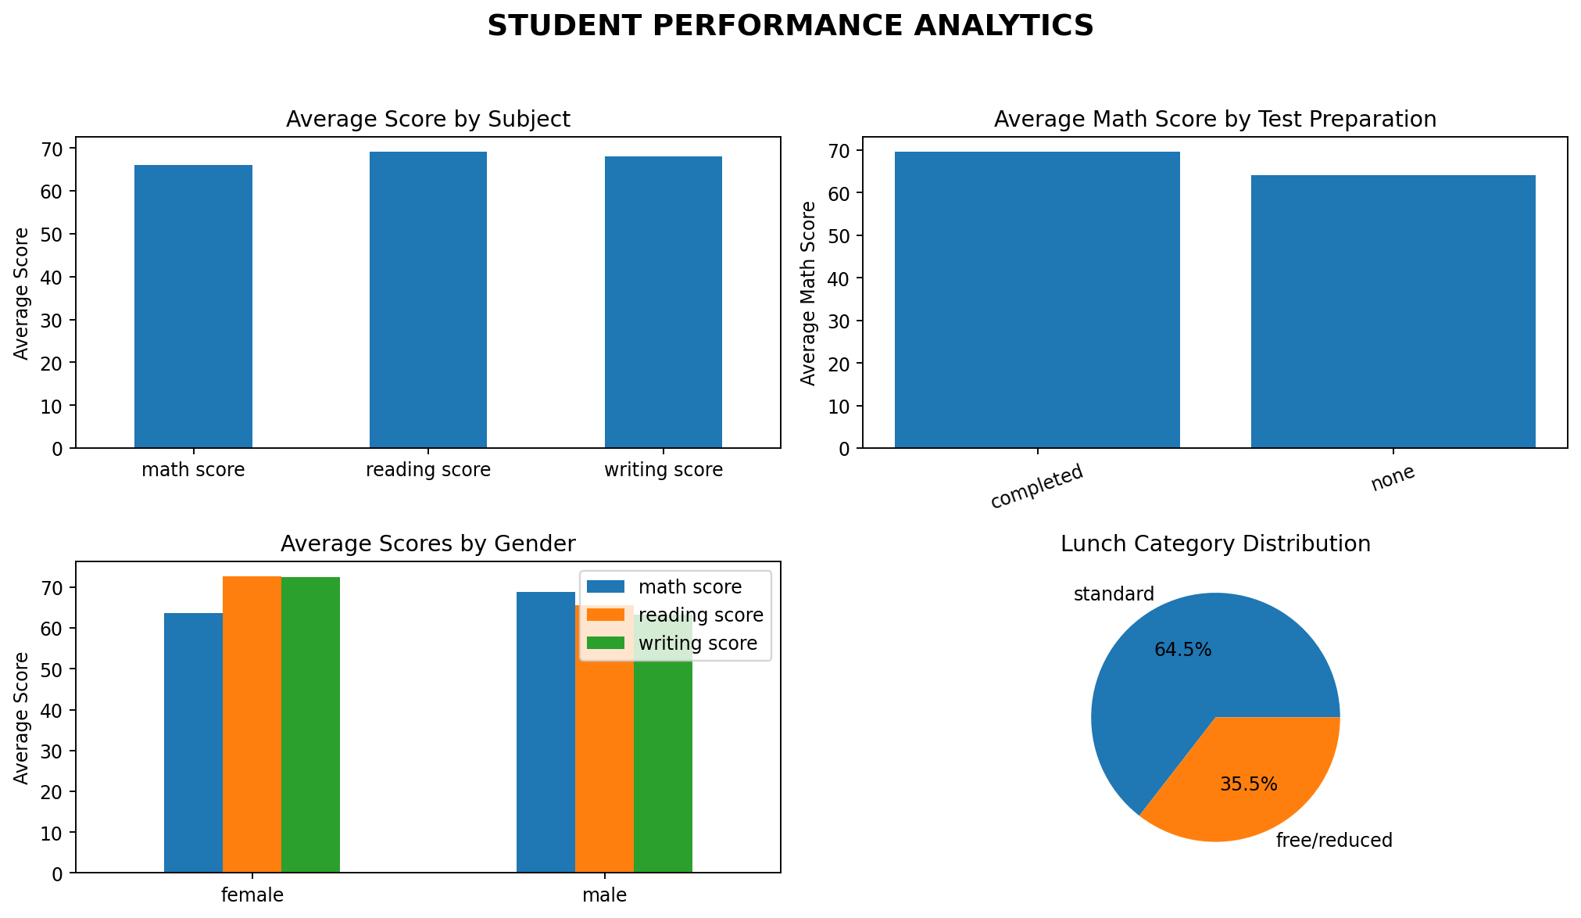
Student Performance Analytics dashboard output based on the StudentsPerformance.csv dataset.
Result:
The Students Performance dataset was successfully imported, transformed, analyzed, and visualized in Power BI using calculated measures, category-wise comparisons, and interactive dashboard visuals.

EXPT NO:6C DATA VISUALIZATION USING POWER BI
(STUDENT PERFORMANCE ANALYSIS)
Aim:
To clean, preprocess, and transform the Students Performance dataset, load the clean data model into Power BI, and build an interactive dashboard to analyze student demographics, academic scores, preparation-course effects, and relationships between subjects.
Algorithm:
1. Import Dataset: Load StudentsPerformance.csv into Power BI using Get Data → Text/CSV.
2. Deduplication: Identify and remove duplicate rows across all fields.
3. Handle Missing Values: Check categorical and numerical columns and replace
or filter invalid/missing values where required.
4. Data Types: Set Math, Reading and Writing Score as Whole Number and categorical fields as Text.
5. Data Cleaning: Standardize values in gender, race/ethnicity, parental level of
education, lunch, and test preparation course.
6. Load Clean Data: Apply the transformations and load the clean table into Power BI Desktop.
7. Create Core Metrics: Create Total Students, Average Math Score, Average Reading Score, Average Writing Score, Total Score, and Average Score.
8. Academic Visualization: Create column charts for subject-wise averages and category-wise performance.
9. Demographic Visualization: Create charts for gender and race/ethnicity distributions.
10. Relationship Analysis: Create a scatter chart for Math Score versus Reading Score.
11. Dashboard Controls: Add slicers for gender, race/ethnicity, parental education, lunch, and test preparation course.
12. Dashboard Design: Arrange cards, charts, and slicers into a meaningful Student Performance Dashboard.
13. Analysis: Use interactive visuals to inspect score distributions and category-wise differences.
14. Save Report: Save the completed Power BI report as a .pbix file.

Output:
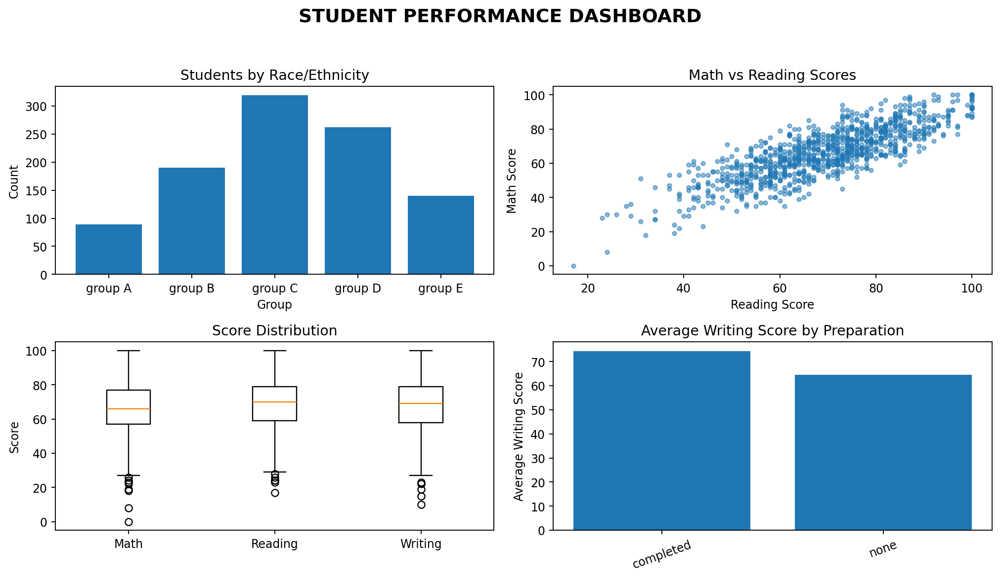
Student Performance dashboard output based on the StudentsPerformance.csv dataset.
Result:
The Students Performance dataset was successfully cleaned, transformed, and visualized in Power BI. An interactive dashboard was created to examine student demographics, subject scores, preparation-course categories, and relationships among academic scores.

